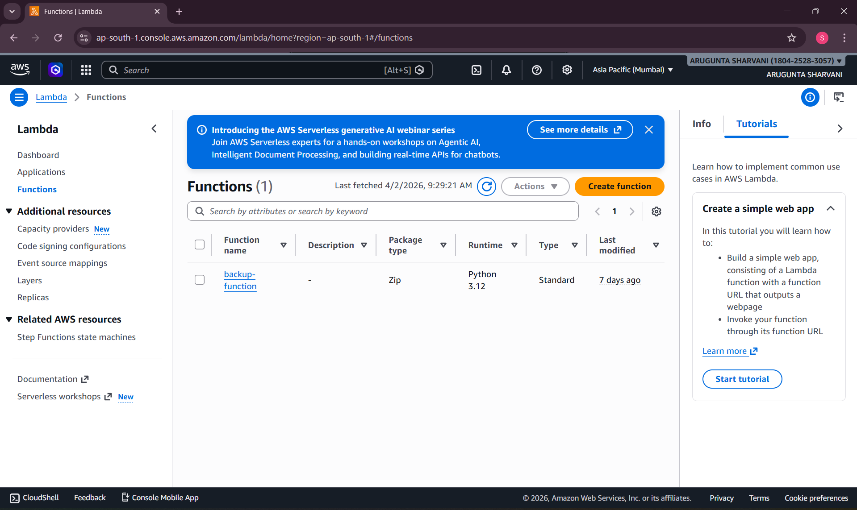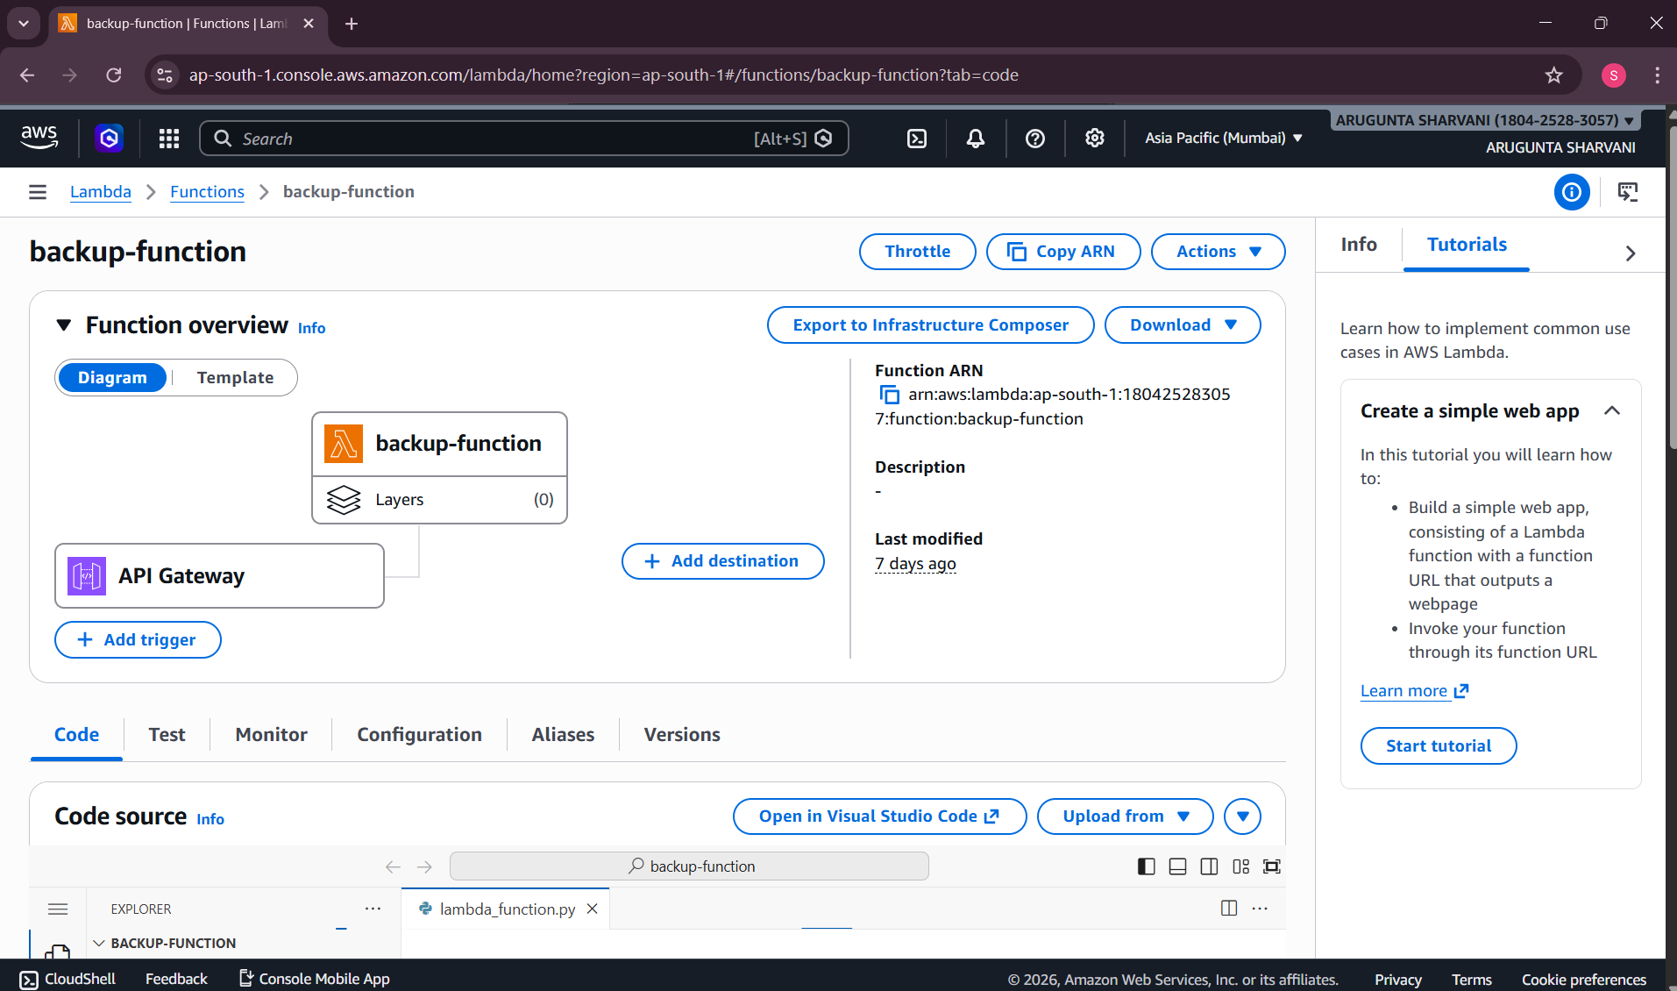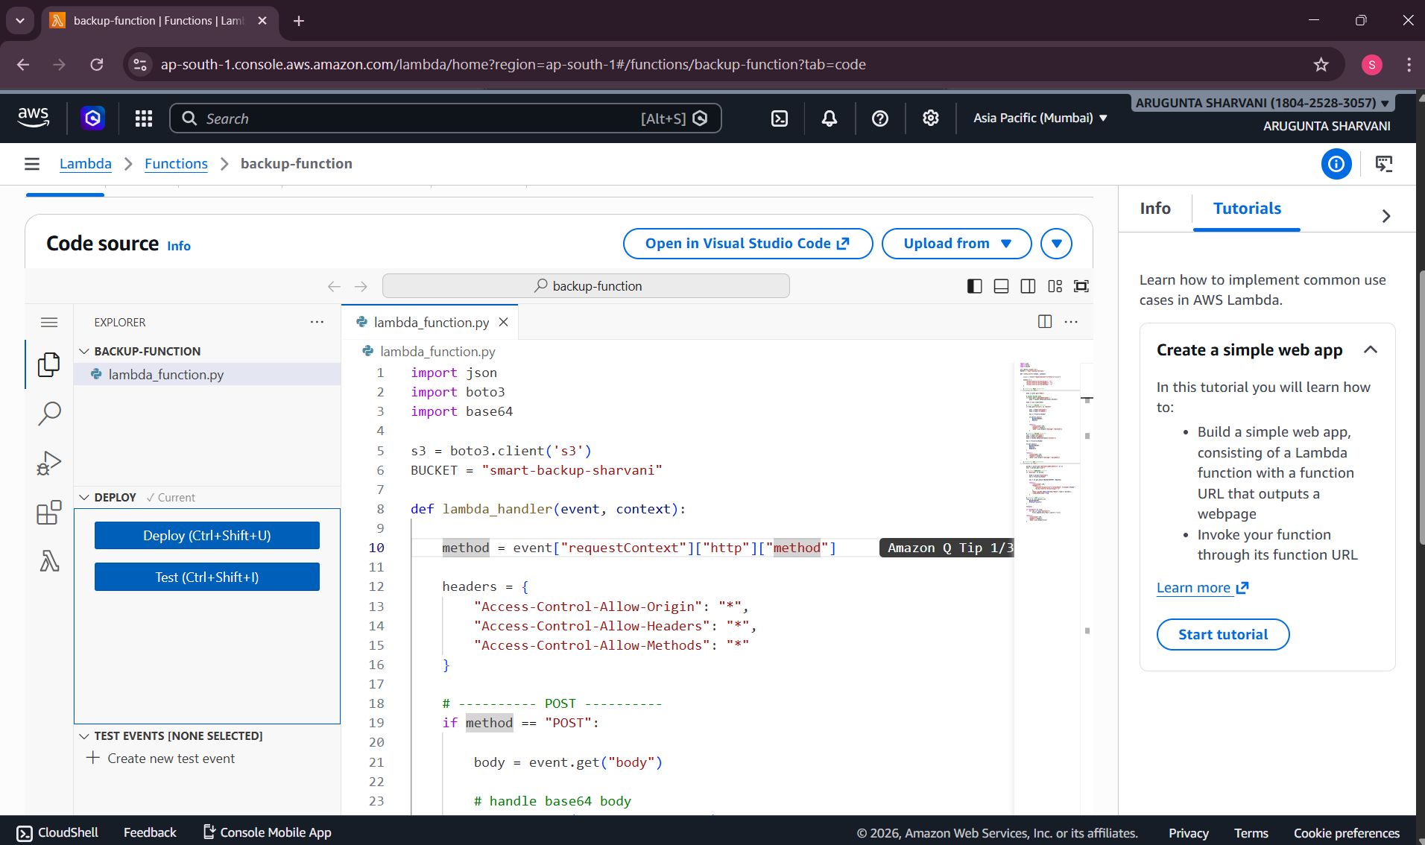
import json
import boto3
import base64

s3 = boto3.client('s3')
BUCKET = "smart-backup-sharvani"

def lambda_handler(event, context):

method = event["requestContext"]["http"]["method"]

headers = {
"Access-Control-Allow-Origin": "*",
"Access-Control-Allow-Headers": "*",
"Access-Control-Allow-Methods": "*"
}

# ---------- POST ----------
if method == "POST":

body = event.get("body")

# handle base64 body
if event.get("isBase64Encoded"):
body = base64.b64decode(body).decode()

body = json.loads(body)

# -------- DELETE --------
if body.get("action") == "delete":

user = body["username"]
file = body["fileName"]

key = f"{user}/{file}"

s3.delete_object(
Bucket=BUCKET,
Key=key
)

return {
"statusCode":200,
"headers":headers,
"body":json.dumps({"message":"deleted"})
}

# -------- UPLOAD --------
user = body["username"]
file = body["fileName"]
data = base64.b64decode(body["content"])

key = f"{user}/{file}"

s3.put_object(
Bucket=BUCKET,
Key=key,
Body=data
)

return {
"statusCode":200,
"headers":headers,
"body":json.dumps({"message":"uploaded"})
}

# ---------- GET ----------
if method == "GET":

params = event.get("queryStringParameters") or {}
user = params.get("user")

# -------- DOWNLOAD --------
if "download" in params:

file = params["download"]
key = f"{user}/{file}"

obj = s3.get_object(Bucket=BUCKET, Key=key)

return {
"statusCode":200,
"headers":{
"Content-Disposition":f'attachment; filename="{file}"',
"Access-Control-Allow-Origin":"*"
},
"body":base64.b64encode(obj["Body"].read()).decode(),
"isBase64Encoded":True
}

# -------- LIST --------
resp = s3.list_objects_v2(
Bucket=BUCKET,
Prefix=f"{user}/"
)

files=[]

if "Contents" in resp:
for obj in resp["Contents"]:
files.append(obj["Key"].split("/")[1])

return {
"statusCode":200,
"headers":headers,
"body":json.dumps(files)
}
